

**PROJECT REPORT**

Course title: Software Project V

Course code: CSE 317

Teacher name: Fariha Jahan

Group name: Exodus

Group members:

Sohel Ashik 191-15-12898

Rahat Islam 191-15-12895

Hasibul Hasan 191-15-12894

Santo Islam 191-15-12896

Gitlink: https://github.com/ashik2580/ETH-and-BTC-data-visualization/blob/main/BTC%20AND%20ETH.ipynb

**Ethereum cryptocurrency data visualization**

**Abstract:** This project goal is data visualization of past years Ethereum cryptocurrency history and build up a decision that investing on this digital currency will be good or not. There is used a forecasting method and some graph to understanding the market perfectly. The goal was to visualize the Ethereum price datasets Python and some of its library Numpy, Pandas, Matplotlib and this project was successfully completed by us. Visualization results are shown using some charts (Bar chart, Horizontal bar chart, Pie chart, Line plot, Scatter plot and Histogram).

**Introduction:** This paper discussed about Ethereum cryptocurrency. Ethereum is a decentralized, open-source blockchain featuring smart contract functionality. Ether (ETH) is the native of the platform. It is the second-largest cryptocurrency by market capitalization, after Bitcoin. Ethereum is the most actively used blockchain.

Ethereum was proposed in 2013 by programmer Vitalik Buterin. Development was crowdfunded in 2014, and the network went live on 30 July 2015, with 72 million coins. The Ethereum Virtual Machine (EVM) can execute scripts and run decentralized applications. Ethereum is used for decentralized finance and has been utilized for many initial coin offerings.

This paper mainly discussed about data visualization of Ethereum cryptocurrency. For this data visualizations we use matplotlib library and we use a dataset which name is Ethereum prices, that is show the past years Ethereum prices history.

**Methodology:**

1.About dataset: This project work in Ethereum prices dataset. This database show the past years Ethereum prices history. This database also show that past year transaction volume, market value, dollar value, exchange value form other cryptocurrency, generated coins which is generated from coin mining, information of Ethereum coin hacking durability and block information. This dataset have 15 column and 1103 rows. This dataset columns name are date, txVolume, txCount, marketcap, price, exchange volume, generated coins, fees, active address, medianTxValue, medianFee, averegeDifficulty, paymentcount, blocksize, blockcount. We are use another two short dataset which is percentage of uses Ethereum in country wise and another dataset is popularity of cryptocurrency coins.

2.Pandas: Pandas is a fast, powerful, flexible and easy to use open source data analysis and manipulation tool, built on top of the Python programming language. Pandas provide extremely streamlined forms of data representation. This helps to analyze and understand data better. Simpler data representation facilitates better results for data science projects. It can efficiently handle large amount of data.

3. NumPy: NumPy is a Python library used for working with arrays. It also has functions for working in domain of linear algebra, fourier transform, and matrices.

4. Matplotlib: Matplotlib is a comprehensive library for creating static, animated, and interactive visualizations in Python. Matplotlib can be used in Python scripts, the Python and IPython shell, web application servers, and various graphical user interface toolkits.

**Results & Discussion**:

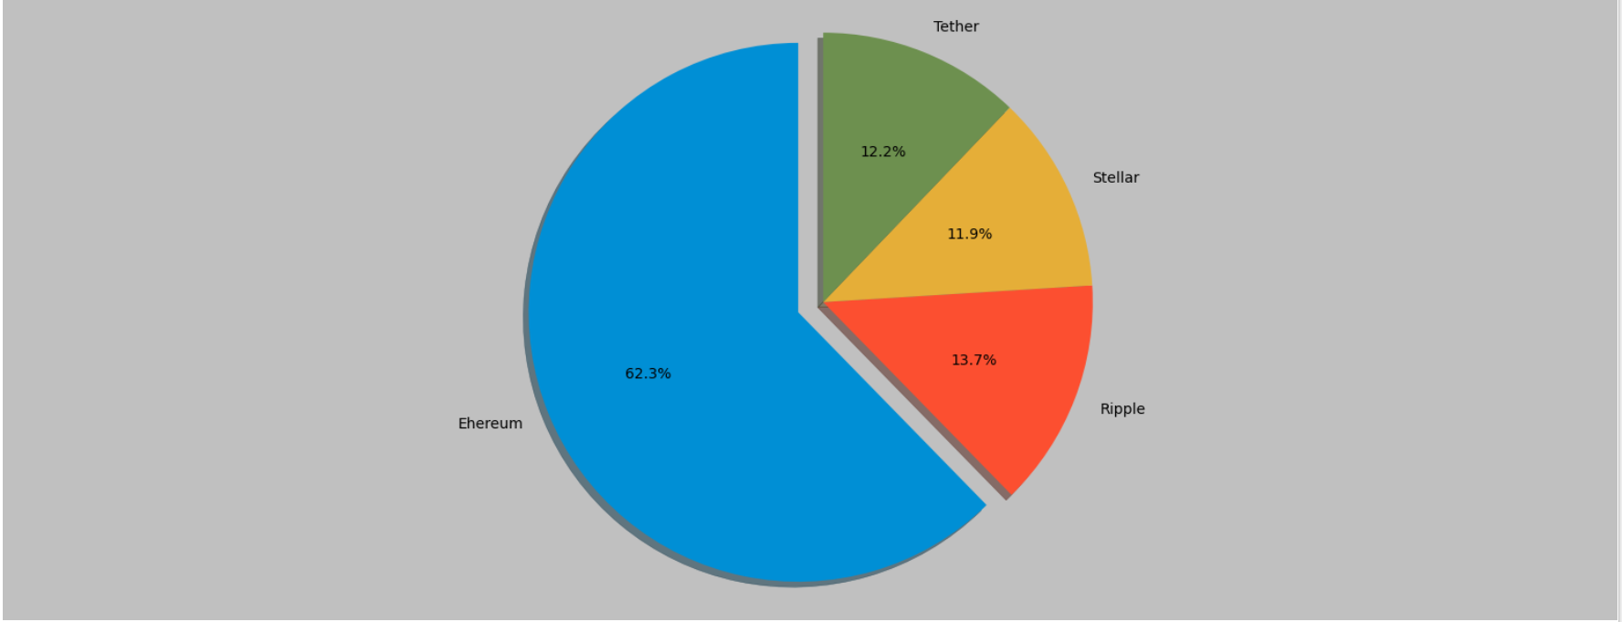

With this graph, the most 4 giant crypto is showing. But since the Bitcoin exhausted most of the market so we dropped the coin.

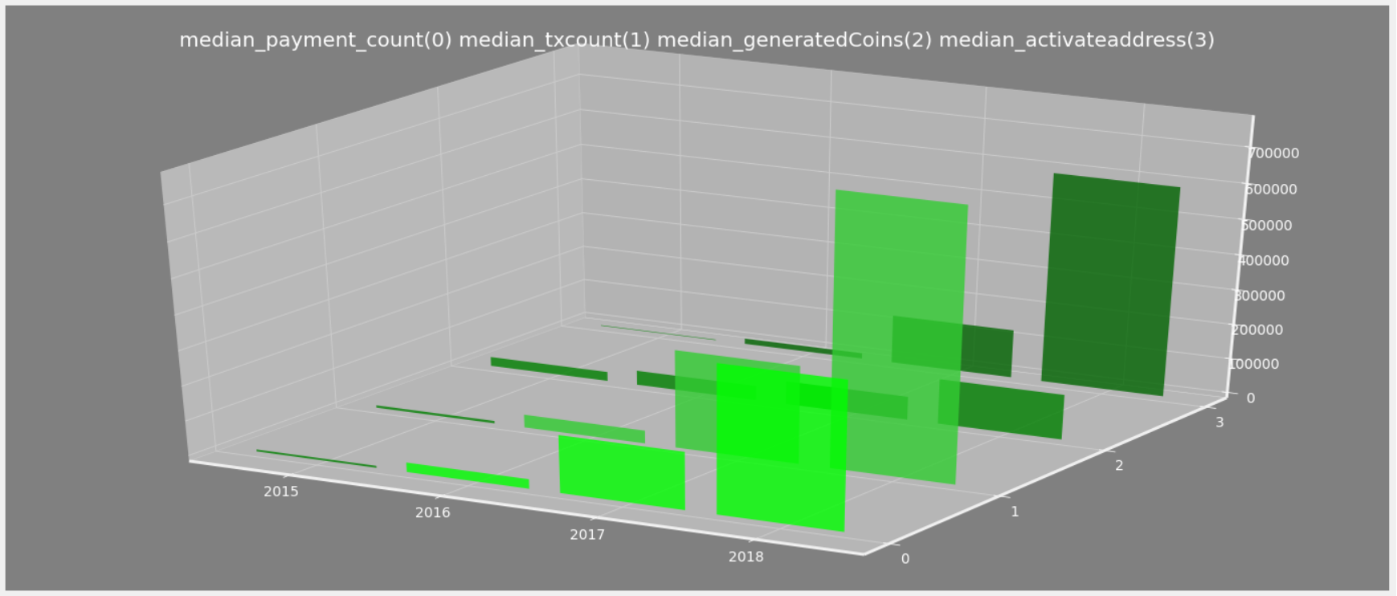

In this 3D graph all the median of payment count, transection count and generated coins are shown against the 4 year 2015-2018.

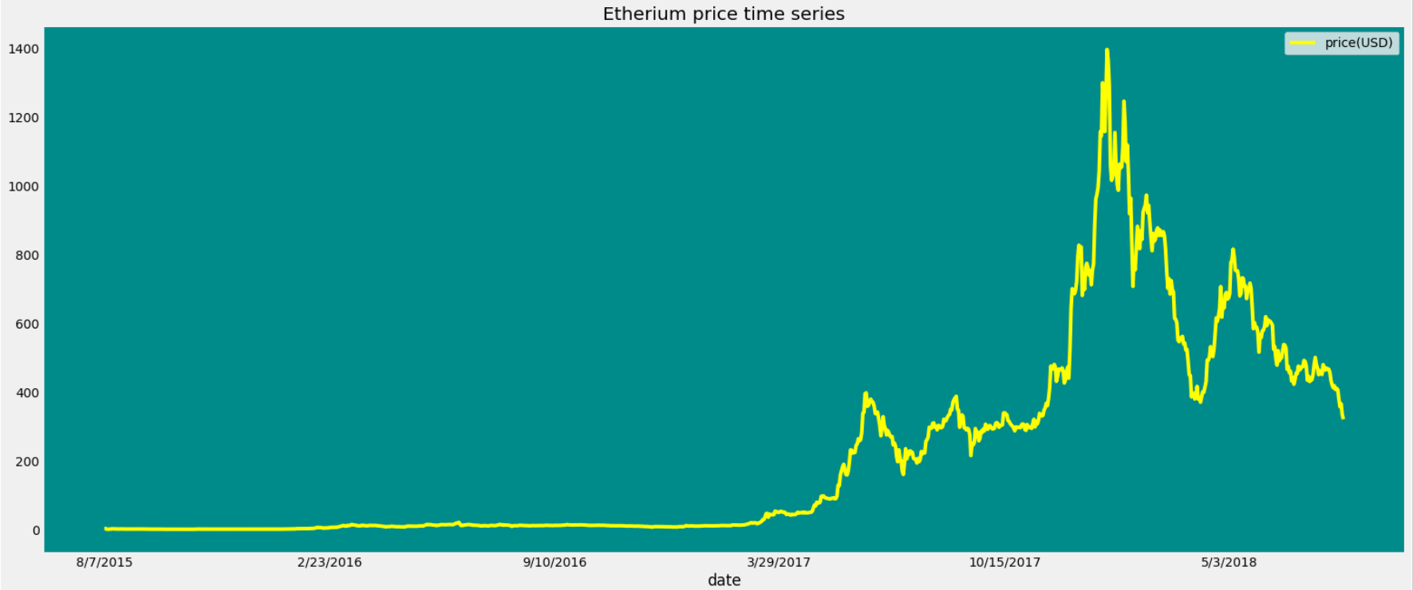

This the time series of ETH.

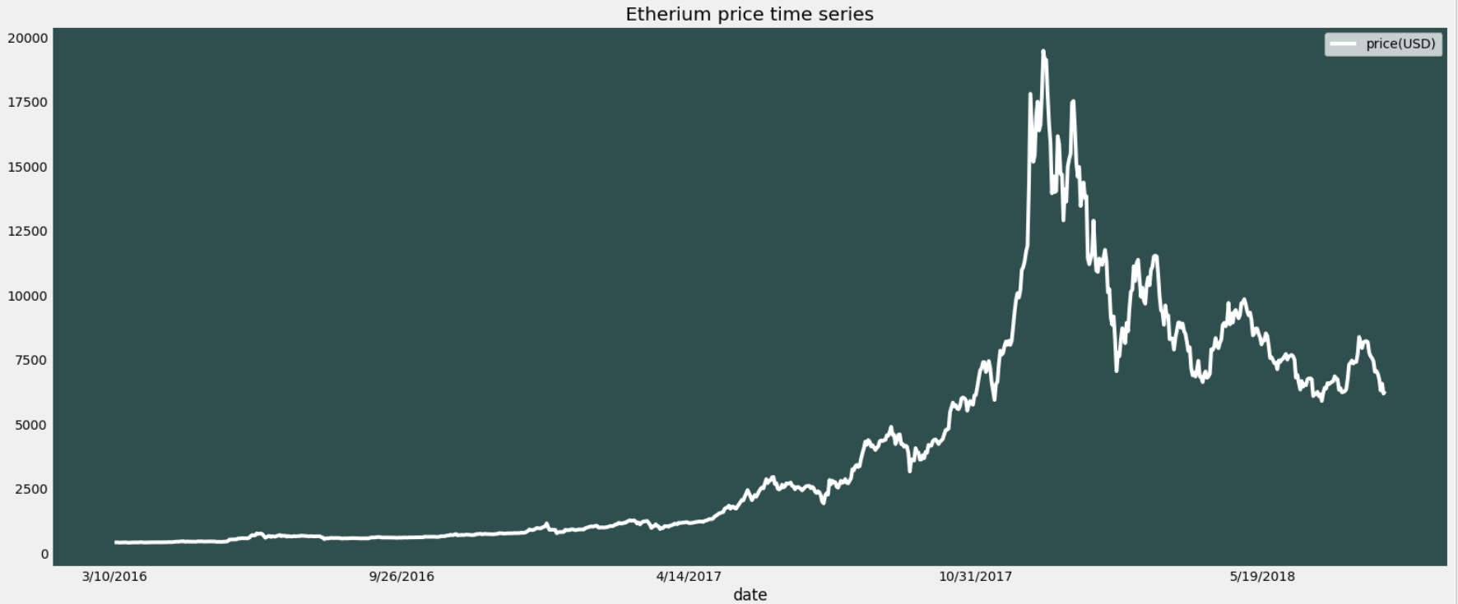

This is the time series of BTC.

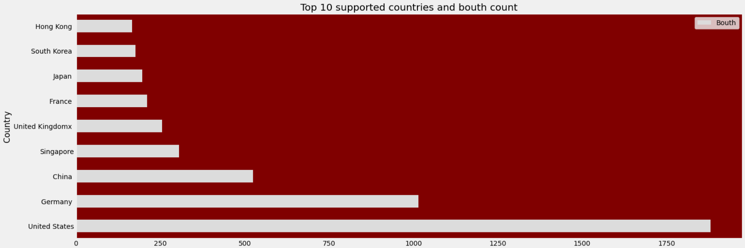

The top 10 countries of supported ETH and their booth counts.

**Conclusion:** The world is being digitalized day by day. The existed transaction system will be banded soon. Cryptocurrencies are being much popular for transactions and they are also being popular for investing as stock market. There is always some risk that ,will the coin last long or not, will the market value will increase or not. And this project is enough to solve all the problem someone can have about Ethereum crypto.

**References:**

[1] Ethereum prices dataset collected from CoinDesk.com.

[2] “Python” – information collected from Wikipedia.

[3] “Pandas” – information collected from Pandas.pydata.

[4] “Matplotlib” – documentation collected from matplotlib.org.

[5] “Google colab” – using google platfrom.